IN THE UNITED STATES DISTRICT COURT
FOR THE EASTERN DISTRICT OF TEXAS
PLANO DIVISION

In re TROY A. SMOCKS

Case Number _______________________

PETITION FOR WRIT OF HABEAS CORPUS AD SUBJICIENDUM
AND EXHIBITS IN SUPPORT THEREOF

I. VENUE

This lawsuit attacks the validity of a federal sentence, for lack of jurisdiction over the person of the Petitioner in the sentencing court, pursuant to 28 U.S.C. § 2241(a), which prescribes:

Writs of habeas corpus may be granted by the Supreme Court, any Justice's thereof, the district courts and any circuit judge within their respective jurisdictions. The order of a circuit judge shall be entered in the records of the district court of the district wherein the restraint complained of is had.

II. SUBJECT MATTER JURISDICTION
This habeas corpus Petition is predicated upon Subsection (c), Subparagraphs (1), (2), and (3) to § 2241, which prescribes:
(c) The writ of habeas corpus shall not extend to a prisoner unless -

- He is in custody under or by color of the authority of the United States or is committed for trial before some court thereof; or

- He is in custody for an act done or omitted in pursuance of an Act of Congress, or an order, process, judgment or decree of a court or judge of the United States; or

- He is in custody in violation of the Constitution or laws or treaties of the United States.

(A) The Petitioner attacks his three years term of Supervised Release under 18 U.S.C. § 3583, imposed by the United States District Court for the District of Columbia, Tanya S. Chutkan, Judge. Case No. 1:21-cr-00198-TSC.

(B) Supervised Release is "in custody" for the purpose of habeas corpus relief, Ojo v. INS, 106 F. 3d 680 (5th Cir 1997) Id at 681. "Supervised Release is punishment; it is deprivation of some portion of one's liberty imposed as a punitive measure for a bad act. A defendant on Supervised Release is subject to various terms and conditions which restrict his freedom and make him vulnerable to further punishment should he violate them. Such subsequent punishment may again include more imprisonment and more Supervised Release." U.S. v. Gilchrist, 130 F. 3d 1131 (3rd Cir 1997) Id at 1134.

III. CAUSE FOR WRIT TO ISSUE WITH URGENCY
The gravamen of this case centers on racial discrimination for reason of political affiliation, and government induced persecution in the course thereof. Troy A. Smocks is a 60 year old black conservative American male, whose political viewpoints aligned with the those of former United States President Donald J. Trump. As a black American, Mr. Smocks’ political viewpoints stand in dire opposition to the status quo and the more common democratically led black American affiliates who support Black Lives Matter (BLM) and its political viewpoints.
In today’s new, so called “Woke” political atmosphere and environment of social “Cancel Culture”, Mr. Smocks has been criminally persecuted for non-other reason than racial intimidation based solely upon his vote casting decision and conservative political viewpoints. The racial discrimination and persecution of Mr. Smocks is evidenced and more fully set out in this Petition for Writ of Habeas Corpus at Section VIII ¶ 26.
The unlawful and retaliatory conduct of government officials in the persecution of this black American falls in direct conflict with Texas Law and Mr. Smocks’ enjoyment of the constitutionally guaranteed right and privilege to immunity against criminal liability based upon politically protected speech. “To punish a person because he has done what the law plainly allows him to do is a due process violation of the most basic sort.” Borkenkircher v. Hayes, 434 U.S. 357, 363 (1978). When adjudicating the "unique class of retaliatory arrest allegation in the federal courts, the allegation must involve objective evidence of an official policy of retaliation formed well before the arrest , in response to highly protected speech that has little relation to the offense of arrest . Lozman v. City of Riviera Beach, 138 S. Ct. 1945, 1955 (2018). However in the instant matter, the protected political speech of Mr. Smocks is the sol[e] offense of arrest. Moreover, the federal government’s official “Shock and Awe” policy as specifically set out in this Petition at Section VII ¶ (A), provides evidentiary value that the government’s policy was clearly in retaliation for the politically induced events which transpired in the District of Columbia on January 6, 2021, an event that Mr. Smocks had nothing to do with.
As part of the government’s unlawful persecution, Mr. Smocks has been (1) label a “Domestic Terrorist”; (2) placed upon the “NO FLY LIST”; (3) Listed in terrorist databases throughout the United States and abroad; (4) had provisions of the “PATRIOT ACT” employed against him which has affectively deprived him of banking, housing, credit, internet access to online business tools, travel restrictions, employment deprivation and has subjected him to social out casting to name just a few of the quality of life privileges afforded to other American citizens.
For years and prior to the government’s unlawful persecution of Mr. Smocks in the matter now before this Court, Mr. Smocks resided in a luxury gated residential community with tens of thousands of dollars in his personal banking accounts. Mr. Smocks was also a small business owner serving the entire state of Texas. Mr. Smocks lived completely debt and care free enjoying international travel afforded solely from the fruits of his own making. Today however, and in the wake of the government’s political persecution, Mr. Smocks’ quality of life has been dramatically reduced to that of a pauper. More specifically, it appears that the only action that this government has failed to take against Mr. Smocks is that of having him physically exiled from the same American that guaranteed his protection.

IV. ABOUT THE PARTY
Troy Anthony Smocks, known from hereinafter as the Petitioner, was released from federal custody predicated upon an Order of Sentence Completion on January 12, 2022. The Petitioner was released from the D.C. Department of Correction, located in Washington, District of Columbia. The Petitioner completed the 14 months of confinement imposed by the United States District Court for the District of Columbia, and is now subject to a three year term of Supervised Release. The Petitioner had failed to receive any type of sentence discharge documents, or travel funds for allowing him to return to his residence state of Texas. Nor did the Petitioner ever receive instructions whatsoever, regarding supervision reporting requirements, or conditions. The Petitioner was merely released from custody penniless, 1348 miles from home, and under freezing winter weather conditions. The Petitioner has a place of contact at 1240 W. Trinity Mills Rd., Carrollton, Texas 75006 which is located within the Eastern District of Texas, for the purpose of federal habeas corpus venue.

V. 28 U.S.C. § 2255 IS INADEQUATE OR INEFFECTIVE IN THIS CASE
In a case where the § 2255 procedure is shown to be inadequate or ineffective, § 2255(e) provides that the habeas corpus remedy shall remain open to afford a necessary hearing. United States v. Hayman, 342 U.S. 205 (1952) Id at 223. The "savings clause" pursuant to § 2255(e) is properly invoked in the instant matter where:
- The sentencing court had no power to enter or impose the sentence, in that, the district court's plea colloquy is contrary to clearly established federal law and has resulted in the conviction of one who is actually innocent, and therefore the sentence cannot legally stand. SEE - State v. Bruce, 488 U.S. 563 (1989);

- The district judge had a political bias, or the appearance of a direct personal interest in the outcome of the Petitioner's case;

- The district court lacked jurisdiction over the "person" of the Petitioner, in that, the government violated federal and state extradition procedural statutes, comity, and the sovereignty of the State of Texas.

VI. CAUSE AND PREJUDICE
Normally, the voluntariness and intelligence of a guilty plea can be attacked on collateral review only if first challenged on direct appeal. Habeas review is an extraordinary remedy and will not be allowed to do service for an appeal. Reed v. Farley, 512 U.S. 339 (1994) Id 354. But where a habeas petitioner has procedurally defaulted on a claim by failing to raise it on direct review, the claim may be raised in habeas corpus, only if the petitioner can first demonstrate among others, "cause and actual prejudice" that he is actually innocent. Bousley v. U.S., 523 U.S. 614 (1998) Id at 496, quoting Murray v. Carrier, 447 U.S. 478 (1986).
"We remain confident that, for the most part, 'victims of a fundamental miscarriage of justice will meet the cause and prejudice standard'. Accordingly, we think that in an extraordinary case, where a constitutional violation has probably resulted in the conviction of one who is actually innocent, a federal habeas court may grant the writ even in absence of a showing of cause for the procedural default". Carrier, Id at 496.

§ 2255(e) is applicable where the statutory remedy is ineffective for providing relief against a sentence imposed by a court for conduct that the law does not make criminal. Under the savings clause to § 2255(e), a § 2241 petition that attacks a federal sentence may be considered, if shown that § 2255 is inadequate or ineffective to test the legality of federal detention. Kelly v. Castaneda, (5th Cir 2018) Id at 2. To satisfy § 2255(e)'s savings clause, the attack must establish that the claim for relief is based on an applicable Supreme Court decision which establishes that the Petitioner may have been convicted of a non-existent offense. To date, the Supreme Court has not provided much guidance as to the factors that must be satisfied for a petitioner to file under habeas corpus provisions such as § 2241. In United States v. Hayman, 342 U.S. 205 (1952) Id at 223, the court simply observed that the habeas corpus writ is available when § 2255 is inadequate or ineffective. Standards in which various federal courts of appeals have articulated for the savings clause may not be framed in identical terms, but the following basic features are evident in most formulations: "actual innocence and retroactivity". Courts have framed the actual innocence factor differently, but the core idea is that the Petitioner may have been imprisoned for conduct that was not prohibited by law. SEE - Reyes-Requena v. U.S., 243 F. 3d 893 (5th Cir 2001) Id at 904. "To capture the idea that the incarceration of one whose conduct is not criminal inherently result in a complete miscarriage of justice." SEE ALSO - Davis v. United States, 417 U.S. 333 (1974) Id at 346. But the petitioner bears the burden of demonstrating that Section § 2255’s remedy is inadequate or ineffective, Pack v. Yasuff, 218 F. 3d 448 (5th Cir 2000) Id at 452. In the instant matter, the Petitioner was sentenced to a term of imprisonment and a subsequent term of Supervised Release predicated upon First Amendment protected political speech, which the Supreme Court of the United States has determined to be, beyond the reach of criminal statutes such as the relevant statute of conviction. "The First Amendment protects those engaged in speech which can be fairly considered as relating to any matter of political, social, or other concern to the community." Snyder v. Phelps, 562 U.S. 443 (2011) Id at 453 and 458.

VII. STATEMENT OF THE CASE

This matter presents exceptional circumstances where the need for the remedy afforded by the writ of habeas corpus pursuant to 28 USC § 2241 (a), under the supervisory powers of the appellate court is apparent. SEE - Hill v. United States, 368 U.S. 424 (1962) Id 428. [T]he statesmen who framed the Constitution were fully sensible, that from the complex character of government, it must fail unless the states mutually supported each other and the general government itself. The Federal Constitution places certain limits on the sovereign powers of the states and on the federal government, limits that are an essential part of the Framers' conception of national identity and Union. One such limit is found in Art. IV, § 2, cl. 2, the Extradition Clause.
(A) THE FEDERAL“SHOCK AND AWE” ARREST CAMPAIGN

Beginning on the date of January 7, 2021, federal prosecutor Michael Sherwin led the largest criminal investigation in U.S. history. Sherwin's team criminally charged hundreds of suspects in relation to the event at the U.S. Capitol on January 6, 2021. “I wanted to see the crowd, gauge the temperature of the crowd; it was like a carnival environment. People were selling shirts, popcorn, cotton candy, I saw hot dogs.” These are the words of Sherwin during March 22, 2021 interview with the 60 Minutes television show https://www.cbsnews.com/news/capitol-riot-investigation-sedition-charges-60-minutes-2021-03-21/ . Federal prosecutors authorized the FBI to conduct what was described as a public “shock and awe” arrest campaign and official policy against American citizens, for in many cases amounting to no more than minor misdemeanor offenses. The government’s “shock and awe” arrest campaigned emboldened federal agents to disregard the bedrock institution of state sovereignty and individual due process right as guaranteed by the Federal Constitution in effort to achieve, maintain, and instill public fear of the federal government for the purpose of political compliance.
The unrestricted actions of participating federal agencies in the “shock and awe” arrest campaign inflicted monetary, physical and emotional damages against government targets, often upon innocent occupants of the targeted domiciles such as small children, pets and spouses. One such casualty of the government’s actions was Annette Kuehne, who suffered a pregnancy miscarriage only one day following the February 11, 2021 assault on her home by heavily armed FBI agents.
“Our 4-year-old was awakened from the chaos. I picked him up and ran downstairs to open the front door. Our house was completely surrounded by armed FBI and law enforcement, armored tactical vehicles, and police vehicles that extended throughout the community. For a second, I didn’t realize that there were about twenty FBI SWAT Team members with semi-automatic rifles pointed at my son and I because I was distracted by the bright red lasers pointed at our faces, chests, and various points on my 4-year-old son and I.”
Annette Kuehne

VII. BACKGROUND AND FACTS
On January 5, 2021, the Petitioner traveled by way of commercial aircraft to Washington, D.C., to attend the January 6, 2021, "Stop The Steal" political rally in support of President Donald Trump. At or about 9:50 am, EST, on January 6, 2021, and while present on the rally grounds of the "Elisp", in the District of Columbia, President Trump, addressed the crowd of approximately one million attendees.
Beginning at approximately 11:00 am until approximately 6:00 pm, on January 6th and unbeknown to Petitioner at the time, cell phone signals were being entirely disrupted specifically in the rally area by undetermined forces, in that, no text messages, cellular phone calls or live streaming video were being transmitted via their devices as intended by the rally attendees. Even President Trump’s personal communication device was affected. SEE - https://www.pcmag.com/opinions/why-cell-networks-cut-out-at-the-us-capitol-riot, SEE ALSO -
“The House committee investigating the January 6 insurrection at the US Capitol is reportedly looking at a “possible cover-up” of White House records focusing on Donald Trump’s phone logs from that fateful day, which bear an unexplained gap of seven hours and 37 minutes covering the period when the violence was unfolding.”
https://www.theguardian.com/us-news/2022/mar/29/trump-phone-logs-capitol-attack-january-6

Ironically an identical anomaly occurred in Washington, DC., just seven month earlier during a Black Lives Matter (BLM) protest on June 1, 2020. SEE - https://www.politifact.com/factchecks/2020/jun/02/tweets/how-false-conspiracy-theory-about-washington-commu/ .
“On June 1, #dcblackout trended on Twitter as Black Lives Matter protests raged in Washington, D.C.”

“The hashtag was shared with posts claiming there was a communications blackout in the nation’s capital to quell unrest over the death of George Floyd in Minneapolis. Washington officials say there was never a blackout.”

During the rally, the Petitioner communicated the first of two politically inspired communications (posts) onto his Parler, social media platform by way of his cell-phone, SEE - (EXHIBIT 1 ). After the electronic communications disruption had expired at approximately 6:00 pm on January 6th, the Petitioner's social media post was viewed upwards of sixty thousand times.
Prior to the transmission of his first social media post, the Petitioner, who had walked from his hotel and half the distance to the rally grounds, decided to return to his hotel in an effort to put on additional layers of clothing because the temperature in Washington, D.C., was near freezing that morning.
While returning to his hotel, the Petitioner encountered four, uniformed District of Columbia Metropolitan Police officers who were gathered at one of the local barricaded Street intersections. The officers who all wore cold weather face masks appeared to be black Americans, three male officers and one female. The Petitioner witnessed one of the male officers utter in a normal speaking tone,
"Morris, did you get that shit from Capitol Police? -- Talking about the Mission change. -- Now, we ain't supposed to fuck up the Trump supporters. -- We only supposed to fuck up the Anti-Trump supporters. -- What the fuck is that suppose to mean? -- How we gonna know the difference?"

The female officer then responded,
"When they call me and I put all that shit on, I'm gonna go over there and fuck all of them up. -- If they bring their dumb white asses over to that Capitol -- I'm fucking them up." SEE - (EXHIBIT 2).

In light of what the Petitioner viewed as a perceived threat of violence by the police and against President Trump supporters, the Petitioner did not attend the "march" to the United States Capitol on January 6, 2021, and elected to remain clear of the immediate Capitol grounds.
At approximately 1:30 pm, EST, on January 6, 2021, severe violence erupted in, and on the grounds of the U.S. Capitol, between U.S. Capitol Police, D.C. Metropolitan Police, and civilian protestors.
The unrest at the Capitol continued until approximately 6:00 pm, EST, when a district-wide curfew was imposed by the D.C. Mayor. From the early morning hours and throughout the entire day, all venues, restaurants, and toilet facilities had been denied to the protestors and ordered to be closed. From the outset, Washington, D.C., was a completely hostile environment towards the visiting supporters of President Trump.
The second of the Petitioner's politically inspired social media post which consisted of one string of previously disrupted post was transmitted at approximately 8: 15 pm. EST, on the same day. SEE - (EXHIBIT 3)
On the morning of January 7, 2021, the Petitioner boarded his return flight from Washington, D.C., to his home in Dallas, Texas.
On January 13, 2021, FBI Special Agent, Kendrick J. Chumak, made investigative contact with the leasing management for the Petitioner's residence under the guise of domestic terrorism, and also begin pre-arrest surveillance of the Petitioner.
On January 14, 2021, Detective Sergeant Jeff Janczyk, of the D.C. Metropolitan Police Department on assignment to the FBI Joint Terrorism Task Force, obtained a Criminal Complaint and Warrant of Arrest against the Petitioner from the United States District Court for the District of Columbia, alleging only the written statutory codification, i.e., "18 U.S.C. Section 875(c)" - "Threats in Interstate Commerce". The Criminal Complaint was devoid of all essential constitutional charging elements. In other words the paper was entirely blank. SEE - (EXHIBIT 4 ).
The telephonic arrest warrant was issued by United States Magistrate Judge Robin Meriweather, District of Columbia, Case Number 1:21-mj-00058. Upon having received the Criminal Complaint and Warrant for Arrest by the Dallas, Texas, field office of the FBI, on January 14, 2021, Special Agent Chumak, obtained a warrant to search the Petitioner's residence and vehicles located at 6606 Mapleshade Lane, Apt 20A, Dallas, Collin County, Texas, 75252 from United States Magistrate Judge Kimberly C. Priest, from the E.D. of Texas. SEE - (EXHIBIT 5)
At 6:35 am - EST, on the date of January 15, 2021, approximately thirty heavily armed (and cladded in military assault gear), members from the FBI (Federal Bureau of Investigation) and DHS (Department of Homeland Security) Joint Terrorism Task Force's SWAT Team, descended upon the Petitioner's residence.
The SWAT Team members arrived at the Petitioner's home in unmarked civilian type vehicles, in addition to one large armored military grade ("MRAP") assault vehicle. There was also the presence of news media in furtherance of the government’s “Shock and Awe” arrest campaign.
The Petitioner was seized by armed members from the SWAT Team, after he had responded to a loud striking sound from a "breach tool" that had been deployed against his front door, followed by a public address speaker's announcement of the FBI's presence.
For more than 20 minutes following his seizure, the Petitioner was forced at gunpoint and while being handcuffed from behind to stand in the middle of his residential street, dressed only in boxer style underwear, and against a thirty four degree near freezing temperature.
At some point thereafter the FBI, began execution of the search warrant upon the Petitioner's residence where a number of items were subsequently removed, including the Petitioner's U.S. Passport that failed to be placed on the Items Seized Inventory Form.
At no time during the government's seizure of the Petitioner, was a member from the Office of the Collin County, Texas Sheriff', or Dallas Police Department in attendance. There was no Texas "peace officer" available for taking custody of the Petitioner, or active in execution of the arrest or search warrants.
At approximately 7:00 am., FBI special agent Chumak placed the Petitioner into an unmarked government car, and transported him directly to the FBI's Dallas, Texas, compound located in the federal Northern District of Texas, and within the extraterritorial jurisdiction of the United States. Prior to this point, the Petitioner had never been informed as to the nature of his abduction.
Following a period of FBI interrogation by Agent Chumak, where the Petitioner denied his intent to threaten anyone by the content of his two January 6, 2021, social media post, Special Agent Chumak, transported the Petitioner from the federal Northern District of Texas, to a United States Courthouse, located in Plano, Texas, and within the territorial Eastern District of Texas.
The Petitioner was then surrendered by Special Agent Chumak, to deputies from the United States Marshal Service, and subsequently arraigned before U.S. Magistrate Judge Kimberly C. Priest, upon the January 14, 2021, federal Criminal Complaint. Thereafter, the Petitioner remained in the custody of the United States Marshal.
On January 21, 2021, a joint Detention Order and Order of Removal was entered by United States Magistrate Judge, Christine A. Nowak, from the federal E.D. of Texas. However, the Magistrate failed to inquire into the Court's personal jurisdiction over the Petitioner by way of the state court's extradition and surrendering processes.
On January 29, 2021, the Petitioner was transported from the territorial Eastern District of Texas, into the territorial Eastern District of Oklahoma, in preparation for his custodial transfer to the District of Columbia.
On February 25, 2021, the Petitioner filed a handwritten, pro se, motion to dismiss the Criminal Complaint for violations of the Speedy Trial Act, 18 U.S.C. § 3161(b). Petitioner filed his pleading in the United States District Court for the District of Columbia, because transportation issues with the United States Marshal Service had stalled the Petitioner's timely transfer to the District of Columbia, hence, affecting the Petitioner's speedy trial rights.
On March 9, 2021, the Petitioner was indicted by a Federal grand jury for the District of Columbia, charging two counts of Threats in Interstate Communications, in violation of 18 U.S.C. § 875(c). SEE - (EXHIBITS 6)
On March 25, 2021, the Petitioner arrived in the District of Columbia. The Petitioner was subsequently arraigned upon the Indictment on March 31, 2021, before U.S. District Judge Tanya S. Chutkan, and appointed counsel, John L. Machado.
On April 7, 2021 and during the Petitioner's Detention Hearing, the district judge offered personal expressions from the bench, where a colorful argument could be made against political interest, and or bias on the part of the judge, and against the alleged conduct of the Petitioner. The court subsequently set oral arguments on the Petitioner's pro se Motion To Dismiss, for April 14, 2021, but denied defense counsel's argument for bail.
On April 14, 2021, and by video, the Petitioner attended oral arguments on his dispositive motion for violations of the Speedy Trial Act.
On May 7, 2021, the district judge entered an Order, denying Petitioner's motion to dismiss.
On July 12, 2021, counsel for the Petitioner filed with the district court a Motion To Reconsider, requesting that the judge correct a number of Supreme Court declared "plain error" rulings that the court had made in the adjudication of the Petitioner's, Motion To Dismiss. SEE - (EXHIBIT 7 Pg 5 ¶ 1- Pg 9 ¶ 1 ) In particular, that the judge had made nunc pro tunc continuances in favor of the government and in violation of the Speedy Trial Act. SEE - (EXHIBIT 7 Pgs 7 - 11 )
On May 29, 2021, the district court denied the Motion to Reconsider without a hearing, and also suspended the remainder of Petitioner's speedy trial rights under the premise of Covid-19.
On August 18, 2021, and under duress (See - https://www.c-span.org/video/?516563-1/representative-marjorie-taylor-greene-news-conference-january-6-defendants) the Petitioner entered into a plea of guilty as to Count One of the Indictment. The district court then ordered a Pre-Sentencing Report (PSR) in advance of the court's acceptance of the plea.
On October 21, 2021, the district court sentenced the Petitioner to a term of 14 months imprisonment in addition to three years of Supervised Release to follow. The district judge sentenced the Petitioner to the high-end of the Federal Sentencing Guidelines in spite of the government's and defense counsel's agreement for a sentence of "time served".
During the Petitioner's sentencing proceeding, and from the bench, the district judge made several what could be argued as politically inspired and biased “January 6th” statements that were adverse to the Petitioner.
On November 4, 2021, a United States Congressional delegation conducted a personal inspection and wellness check upon the Petitioner and other similarly situated January 6th, detainees at the D.C. Jail, followed by a written Report. SEE - https://greene.house.gov/unusually-cruel.
On January 12, 2022, the Petitioner was discharged from federal custody, and traveled from the D.C. Jail, back to the state of Texas, this petition for habeas corpus relief diligently followed.
VIII. THE PLEA OF GUILTY AND SUPERVISED RELEASE
(a) The sentencing district court had no power to enter or impose its sentence against the Petitioner, for reasons that the court's plea colloquy was defective and resulted in the conviction of one who is actually innocent.
A plea of guilty is constitutionally valid only to the extent it is "voluntary" and "intelligent". But where neither council, nor the court correctly understood the essential elements of the crime with which the Petitioner was charged, the plea is be contrary to the determination of law as expressed by the Supreme Court in: Watts v. United States, 394 U.S 705 (1969); Rogers v. United States, 422 U.S. 35 (1975); Virginia v. Black, 538 U.S. 343 (2003); Citizens United v. Fed. Election Comm'n, 558 U.S. 310 (2010); Elonis v. United States, 135 S. Ct. 2001 (2015); and Constitutionally invalid.
"By contrast, decisions of the Court holding that a substantive federal criminal statute does not reach certain conduct, like decisions placing conduct beyond the power of the criminal law making authority to prescribe, necessarily carry a significant risk that a defendant stands convicted of an act that the law does not make criminal." Bousley, supra.

The district court cannot accept a plea of guilty unless the factual basis is specifically adequate to allow a reviewing court to determine whether the defendant's conduct was within the ambit of the statute's prohibitions. SEE - U.S. v. Gobert, 139 F. 3d 436 (5th Cir 1998) at 439.
The guilty plea entered into by the Petitioner, was done so unintelligently because the district court neglected to inform him as to the essential elements of an § 875(c) offense. The core idea is that the Petitioner has been convicted and imprisoned for conduct that is not prohibited by law. SEE - Rayes-Requena, Id at 904. "If one has been imprisoned for non criminal conduct, he meets the actual innocence prongs of the savings clause test."
Where a plea of guilty is at issue, the Supreme Court has thus, explained its holdings in more clearer terms, SEE - Carthy v. United States, 394 U.S. 495 (1969) Id at 467-68. "Rule 11 also requires the judge to satisfy himself that there is a factual basis for the plea. The judge must determine that 'the conduct which the defendant admits constitutes the offense charge in the Indictment or Information' -- Requiring this examination of the relations between the law and the act the defendant admits having committed, is designed to protect the defendant who is in the position of pleading voluntarily with an understanding of the nature of the charge but[] without realizing that his conduct does not actually fall [within the charge."] (Citations omitted) (Emp added). SEE ALSO - United States v. Broce, 488 U.S. 563 (1989) Id at 570.
On January 6, 2021, the Petitioner transmitted two politically framed speech communications (while present at a political event) by way of his internet social media platform. The first communications ("post"), in its entirety represents:
"Today, January 6, 2021, we Patriots by the millions, have arrived in Washington, D.C., carrying banners of support for the greatest President the world has ever known. But if we must… Many of Us will return on January 19, 2021, carrying Our weapons, in support of Our nation's resolve, to which the world will never forget!!! We will come in numbers that no standing army or police agency can match. However, the police are NOT Our enemy, unless they choose to be! And who will not stand with the American Patriot… or who cannot stand with Us… then, that would be a good time for you to take a few vacation days. The American Patriot." SEE - (EXHIBIT 1)

The second communication ("post"), in its segmented parts represents as was alleged:
"Today Eric Trump said that he would physically fight with the Patriots to save Our country. Today Representative Mo Brooks asked the Patriots to pledge our lives and wealth to fight for Our country. And today President Trump told Us to "fight like hell". He said that this cause was a matter of national security, and that these people behind the massive fraud must be arrested and brought to justice. And that task falls on the shoulders of We The People... The American Patriot. So over the next 24 hours, I would say, let's get our personal affairs in order. Prepare our weapons, and then go get'em. Let's hunt these cowards down like the traitors that each of them are. This includes RINOS, Dems, and Tech Execs. We now have the green light. All who resist Us, are enemies of Our Constitution, and must be treated as such. Today, the cowards ran as we took the Capitol. They have it back now, only because we left. It wasn't the building that We wanted... It was them!" SEE - (EXHIBIT 3)

Title 18 U.S.C. § 875(c), prescribes that:
Whoever transmits in Interstate or foreign commerce any communication containing any threat to kidnap any person or any threat to injure the person of another, shall be fined under this title or imprisoned not more than five years, or both.

The statue generally allows for the legislative regulation of unprotected speech. Accordingly, the Supreme Court of the United States, has determined that at least one class of speech under the First Amendment, is beyond the reach of criminal penalties prescribed by Section § 875 (c). This class of protected speech is known as "political speech", or "political hyperbole".
Merriam-Webster Dictionary, defines the term "hyperbole" to mean:

noun- hy*per*bo*le, extravagant exaggeration.

Watts v. United States, 394 U.S. 705 (1969), was the first Supreme Court to rule that threatening types of political hyperbole does not fit within the statutory terms of Sections §§ 871 and 875(c) Id at 708, thereby effectively shielding this political class of speech against criminal prosecution. But, Watts, would not be the last Supreme Court to make such a determination of law. "The First Amendment protects against the government." United States v. Stevens, 559 U.S. 460 (2010). However, the prosecution against the Petitioner in the instant matter is of itself evidence of the danger in putting faith in government prosecutorial restraint where politics are at issue. In Gertz v. Weich, 418 U.S. 323 (1974) Id at 342, Justice Alito recognized the possibility of a First Amendment issue where political speech could be involved. "It can be argued that section 875(c), if not limited to threats made with intent to harm, will chill statements that do not qualify as 'true threats', e.g., statements that may be literally threatening but are plainly not meant to be taken seriously."
Prior to Watts, every federal district and circuit court of appeals adopted what had been termed, the "objective construction" standard in relation to all Section §§ 871 and 875(c) prosecutions. Under the objective construction standard, it would support the conviction of anyone making a statement that would reasonably be understood as a threat, so long as the defendant intended to make the statement, and knew the meaning of the words used; or a reasonable person in the defendants place would have foreseen that the statements made to be understood, as indicating a serious intent to commit the act. The Watts, Supreme Court, held that politically charged speech was [not] a "true threat", but merely hyperbole.
Following Watts, the Supreme Court in Rogers v. United States, 422 U.S. 35 (1975), prohibited Sections §§ 871 and 875(c) from having such a broad construction, that there be a substantial risk of conviction for a merely crude or careless expression of a political enmity. Id at 44.
The provisions, constitutionally protects political speech because of the possibility that the government will prosecute and potentially convict somebody engaging only in political speech, at the core of what the First Amendment is designed to protect. SEE - Virginia v. Black, 538 U.S. 343 (2003) Id at 365. But Watts neglected to define the term, "true threat". Black, was the first Supreme Court to unambiguously establish the judicial meaning for the term "true threat". Black, determined that "a true threat encompasses those statements where the speaker means to communicate a serious expression of intent to commit an act of unlawful violence to a [particular] individual or group of individuals." Id at 357.
The Rogers court determined that, applying the statutes with an eye to the danger of encroaching on constitutionally protected political speech, "fell outside the reach of criminal statutes [AS A MATTER OF LAW"]. Id at 44. (Emp added)
Rogers, further held that objective construction, also embodies a "negligence standard", which charges the defendant with responsibility for the effect of his statements on his listeners. Id at 47. The court went on to determine that a negligence standard was not intended in criminal statutes. Accordingly, barring criminal prosecutions from the protected class of political speech. "The language of the political arena, like the language used in labor disputes, is often vituperative, abusive, and inexact." Watts, Id at 708. "...and often speaks bluntly and recklessly, embellishing their respective positions with imprecatory language." Linn v. United Plant Guard Workers of America, 383 U.S. 53 (1966) Id at 58.

(b) The government failed to charge the essential element of the "recipient" or hearer who is familiar with the context of the communications. Nor did the government allege a "victim" to the charged threat(s), thereby violating the fair notice requirements and confrontation clause to Amendment Six.
There is something deep in human nature that regards face-to-face confrontation between the accused and accuser, as essential to a fair trial in a criminal prosecution. Coy v. Iowa, 487 U.S. 1012 (1988). Id at 1018.
In Count One to the Indictment, the government specifically charges:
"On or about January 6, 2021, within the District of Columbia, the defendant, Troy Anthony Smocks, knowingly and willfully did transmit in Interstate or foreign commerce a communication using a social media service, and the communication contained a threat to kidnap and injure law enforcement officers, specifically."

Count Two to the Indictment, specifically charges:
"On or about January 6, 2021, within the District of Columbia, the defendant, Troy Anthony Smocks, knowingly and willfully did transmit in Interstate or foreign commerce a communication using a social media service, and the communication contained a threat to kidnap and injure politicians and executives in the technology industry, specifically."

Because the Government is defending a restriction on speech as necessary to prevent an anticipated harm, it must do more than “simply posit the existence of the disease sought to be cured.” Colorado Republican Federal Campaign Comm. v. Federal Election Comm’n, 518 U. S. 604, 618 (1996). See also - Federal Election Commission v. Ted Cruz For Senate et al. No. 21–12. Argued January 19, 2022—Decided May 16, 2022.
The government must instead point to “record evidence or legislative findings” demonstrating the need to address a special problem.
18 U.S.C. § 875(c) requires specificity, whereas the government must provide to the defendant, the name(s) of the "recipient" to the transmitted communication(s), who is also familiar with the con[text] of the language communicated. This is a judicially imposed essential element of the charged offenses because it is the recipient who must first determine from the context, if the received communication or otherwise content should be considered a serious threat, or merely a joke towards a particular "victim".
In Elonis v. United States, 135 S. Ct. 2001 (2015), the Supreme Court held that a threat under Section § 875(c), requires the interpretation of a reasonable recipient familiar with the context of the communication. Id at 2019. Accordingly, the government failed to allege or plead within the four corners of its Indictment any recipient whatsoever, and no victim(s). This action clearly violates the confrontation clause and the fair notice requirements to Amendment Six of the Constitution. "Notice and Indictment requirements ensure that before persons held for crime shall be convicted, there shall be an allegation made against them of every element of the crime which the law makes essential to the punishment to be inflicted." Apprendi v. New Jersey, 530 U.S. 466 (2000) Id at 560(c).
The Apprendi, court went on to acknowledge that, "...an accusation which lacks any particular fact which the law makes essential to the punishment, is no accusation in reason-" [T]his error within the Petitioner's Indictment is fatal to both Counts, and could not have been cured through a bill of particulars, for reasons that a "recipient" nor "victim'' to the alleged threats simply does not exist. Accordingly, both Counts to the Indictment should have been dismissed, and no plea of guilty should have been accepted.
Finally, Elonis, consider the mens rea element to Section § 875(c), after adopting the negligence standard from Rogers, supra. Id at 2011. The Elonis court modified the objective standard's [new] companion, which is today's "reasonable person's" standard. Such as, how an internet social media post would be understood by a reasonable person. This standard is a familiar feature of civil liability in tort law, but again, is inconsistent with criminal statutes. Id at 2011.
To fully understand the reasonable person standard requires revisiting its origin, United States v. Dutsch, 357 F. 2d 331 (4th Cir 1966). In this case, James Dutsch was prosecuted under 18 U.S.C. § 875(b), for extortion by threats against his adopted mother. At trial, the mother testified that her son had communicated a telephone call stating that, "... You can have the law there, or whatever you please, but... I'll not miss this time." The prosecution then asked the witness the significance of the words, "I'll not miss this time." Before she was permitted to explain, the court admonished the jury that evidence of any prior incident was relevant to show only: (a) whether Dutsch intended a threat by the use of the quoted language; and (b) whether the call was of such a nature as reasonably to have induced fear in his mother. The words over the telephone, otherwise arguably ambiguous, became clear only in light of the 1960 shooting involving her son. Id at 333. From this case, the reasonable person standard was created.
The Elonis court, adopting the holding in Watts, stated: "Because 875(c) criminalizes speech, the First Amendment requires that the term "threat" be limited to the narrow class of historically unprotected communications called "true threats." To qualify as a true threat, a communication must be a serious expression of an intention to commit unlawful physical violence." Id at 2018. Accordingly, in adopting the holding in Watts, the Elonis, court [again] excluded "political hyperbole", from reach of the Section § 875(c) criminal statute. Id at 2019. The Elonis court further removed the ambiguity from the statutory term "any person" as used in § 875(c). In that, the court held that a threat cannot be determined solely by the reaction of the recipient, who, in the statutory content of “any person” may read the communication.
"[But], must instead be determined by the interpretation of a reasonable recipient familiar with the context of the communication." ** "...less historically protected speech be suppressed at the will of an eggshell observer." Id at 2019. (Emp added).

Collectively, the Watts, Rogers, Black, Citizens, and Elonis, Supreme Courts, have effectively: (1) prohibited political speech and hyperbole from criminal prosecutions under Sections §§ 871 and 875(c); (2) prohibited the “objective construction” standard to Sections §§ 871 and 875(c) prosecutions; (3) prohibited “negligence” standard prosecution's under Section §§ 871 and 875(c) and; (4) modified the “reasonable person” standard to Section § 875(c) prosecutions.
It is uncontested from the Indictment, Statement of Facts, and other parts of the record that the Petitioner's social media posts contain no essential elements of the criminal statute in which he was convicted, e.g.; (1) there is no "recipient" or hearer either reported or pleaded by the government. Here the sentencing court's conviction rests in violation of the principles established by the Supreme Court in, Cohen v. California, 403 U.S. 15 (1971), wherein the court determined that First Amendment protected political speech and expression is "clearly not directed to the person of the hearer." Id at 20.
In the Petitioner's case:
(1)no such recipient or hearer is alleged by the government to have even existed. SEE - (EXHIBIT 8 ¶ 3 - 16);

(2) there is no victim to the alleged threat. SEE - (EXHIBIT 9 ¶ 4) SEE ALSO - (EXHIBIT 10 ¶ 13). "Person of another" as used in § 875(c) is an umbrella term used by Congress to organize a broad set of crimes. Borden v. United States, 141 S. Ct. 1817 (2021) Id 1829. The person of another requires a "known victim" *** "because his conduct is not opposed to or directed at another, he does not come within the elements clause." Id at 1827. A "'true threat' encompasses those statements where the speaker means to communicate the serious expression of an intent to commit an act of unlawful violence to a [particular individual]." Bell v. Hawamba Cnty Sch Bd. 774 F. 3d 280 (5th Cir 2015) Id at 300;
(3) There is no traditional "fighting words'' within the communicated posts, e.g., epithets (a) directed at the person of the hearer; (b) inherently likely to cause a violent reaction; (c) play no role in expression of ideas. SEE - Chaplinsky v. State of New Hampshire, 315 U.S. 568 (1942). Id at 572;

(4) There is no criminal mens rea to the charged offenses. "The general rule is that a guilty mind is a necessary element in the Indictment and proof of every crime." Elonis, supra, Id at 2009. "In determining Congress's intent, we start from a long-standing presumption, traceable to the common law that Congress intends to require a defendant to possess a culpable mental state regarding each of the statutory elements that criminalizes otherwise innocent conduct." Rehaif v. United States, 139 S. Ct. 2191 (2019). Id 2195;
and (5) the term "weapon" as relied upon by the government to predicate its prosecution, is an ambiguous term of art which Congress has failed to define within the United States Code. Cohen, supra, further determined that, "...it is nevertheless often true that one man's vulgarity is another's lyrics. Indeed, we think it is largely because government officials cannot make principled distinction in this area that the Constitution leaves matters of taste and style so largely to the individual." Id at 25.

The Court is urged to take judicial notice of the recent political ad (link attached hereto) that was transmitted in interstate commerce during a June 20, 2022 nationally televised advertisement campaign by Missouri U.S. Senate candidate Eric Greitens.
In the subject-matter communication it is unambiguously stated by Greitens that “RINOS” aka (Republicans In Name Only) must be violently hunted down at gunpoint. See - https://gettr.com/post/p1ey3cxd8a5 and yet no federal interstate commerce related threat charges have been produced against Greitens (a white American male) for reasons of constitutionally protected speech. Mr. Smocks’ political speech was by far less aggressive than that of Greitens, and therefore Mr. Smocks is entitles to the same constitutionally guaranteed protection against arbitrary persecution and criminal prosecution fostered by constitutionally protected political speech. However, it clearly appears that for Mr. Smocks, i.e., the black American conservative male, no such constitutionally protected political speech exist save for Mr. Smocks’ ability to vindicate his constitutionally guaranteed due process and equal protection rights against racially motivated political discrimination and persecution before thi[s] Honorable Court.
Because the Petitioner's claim is, inter alia, that his conduct constitutes political speech which is a class of protected speech under the First Amendment to the Constitution, his conduct of conviction as held by United States Supreme Court decisions on the subject matter cited supra, rest beyond the reach of the 18 U.S.C. § 875(c) criminal statute, and that the Petitioner was; (1) confined in prison; and (2) is further restrained of liberty under the imposition of a term of Supervised Release for non criminal conduct.
For all the reasons presented, the Petitioner clearly meets the actual innocence prong to the § 2255(e) savings clause for habeas corpus relief.

IX. DEFENSE COUNSEL WAS NOT INEFFECTIVE IN LIGHT OF THE CIRCUMSTANCES
Defense counsel was prevented from attacking the legal issues as set out in Section VII, to this Petition for reasons that pursuant to Rule 12, F.R.Crim.P., and when considering a motion to dismiss, a federal district court is bound by the four corners of the indictment, United States v. Lyle, 742 F. 3d 434 (9th Cir (2014); United States v. Huet, 665 F. 3d 588 (3d Cir (2012); U.S. v. Welch, 327 F. 3d 1081 (10th Cir 2003). Accordingly, the government intentionally drafted the Indictment against the Petitioner in a manner, so as to misrepresent the context of the communications, whereas, the drafted Indictment omitted all political content from the alleged threatening language to both social media posts. In that, no context or nexus to First Amendment protected political speech would appear within "the four corners"of the Indictment. COMPARE - (EXHIBITS 6) to (EXHIBITS 1 and 3). "First Amendment rights are ultimately a question of law for the trial court." Schneider v. City of Atlanta, 628 F. 2d 915 (5th Cir 1980) Id at 919. "We regard the ultimate determination of whether an individual's speech was constitutionally protected to be a question of law." Brown v. Bullard ISD, 640 F. 2d 651 (5th Cir 1981) Id at 653. In First Amendment cases the Supreme Court imposes that inferior courts examine independently the whole record to be sure that the judgment does not constitute a forbidden intrusion on the field of expression. SEE - Moore v. City of Kilgore Texas, 877 F. 2d 364 (5th Cir 1989) quoting Rankin v. McPhereson, 483 U.S. 378 (1987).

X. JUDICIAL BIAS
§ 2255 is inadequate or ineffective for the reason that the district court judge had actual bias, or the appearance of bias, or a direct personal political interest in the outcome of the Petitioner's case. Moreover, the entire record is permeated with favoritism towards the government, and unrelenting unfairness towards the Petitioner.
Due process requires a fair trial before a judge without actual bias against the defendant or an interest in the outcome of his particular case. Bracy v. Gramley, 520 U.S. 899 (1997). It certainly violates the Fifth Amendment and deprives the defendant in a criminal case of due process of law to subject his liberty or property to the judgment of a court, the judge of which has a direct, personal, or a substantial pecuniary interest in reaching a conclusion against him in his case. Tumey v. Ohio, 273 U.S. 510 (1927) Id 523.
The politically induced event in the District of Columbia, on January 6, 2021 was fostered by what could be argued as, the most heated and socially divisive general election season in the nation's history. The racial, social, and political divisiveness which resulted from the presidential campaigns between Donald Trump, and Joseph Biden, enabled political bias to infect every facet of the American societal infrastructure to include but not limited to: livelihoods, freedoms, personal health, private business, childhood education, transportation and commerce, legislation, military affairs, law enforcement, and even the federal courts. Further, many individuals who lived in, or worked within the District of Columbia, appear to have taken personal offense towards the U.S. Capitol protestors from January 6, as though the political event involving the Capitol protestors was a direct attack taken against the local District of Columbia residents themselves. District Judge Tanya S. Chutkan, being one of such residences or employees.
On more than three occasions during the Petitioner's criminal proceeding, Judge Chutkan, in effect:
- Acted as an advocate for the Democratic political party, for which she is a registered member, and had been appointed to the federal bench by President Barack Obama; SEE - (EXHIBIT 7 Pg 9 ¶ 2 )

- Became a part of the prosecution and assumed an adversarial role against the Petitioner; SEE - (EXHIBIT 11 Pg 44 ¶ 21 - 25; Pg 45 ¶ 24 - 25 and; Pg 46 ¶ 1 - 5)

"These people, these congressional representatives, their staffs, and law enforcement officers who tried valiantly, even though they were outnumbered, to try to do their job that day, were the real heroes of that day, yet Mr. Smocks has the audacity to call the rioters who sought to violently overturn the legitimate election 'patriots.'"

"I disagree with the proposition that the Department of Justice has been uneven given that there were people demonstrating, largely peacefully, for civil rights arising out of the murder of an unarmed man. That is not the same as an attempt to violently disrupt operations of Congress. Those two are not the same. That is a false equivalence. And I have said it before, and I will say it again."

3. In passing on guilt or innocence of the Petitioner, the district judge ignored plain errors as clearly determined by the Supreme Court, when such errors were promptly called to the Court's attention in regards to the recognition of Political Speech; SEE - (EXHIBIT 11 Pg 28 ¶ 2 - 3)

"THE COURT: That's open to a lot of debate, but that's a political question and certainly not one that I'm going to - -"

A decision is contrary to clearly established federal law if the District Court decides a case differently than the Supreme Court has on a set of material indistinguishable facts. Watson v. Johnson, (E.D. Tex 2017) Id at 4.

4. relied upon her own personal beliefs or political impressions as to what had actually occurred on January 6, 2021, and having a political nexus to the Petitioner's charged offenses. Impressions that could not be tested by adequate cross-examination. SEE - (EXHIBIT 11 Pg 45 ¶ 24 - 25; Pg 46 ¶ 1 - 5 ).

"I disagree with the proposition that the Department of Justice has been uneven given that there were people demonstrating, largely peacefully, for civil rights arising out of the murder of an unarmed man. That is not the same as an attempt to violently disrupt operations of Congress. Those two are not the same. That is a false equivalence. And I have said it before, and I will say it again."

In Beck v. Washington, 369 U.S. 541 (1962) at 581, the Supreme Court determined that a conviction obtained in either a state or federal court cannot be sustained, when the condition was composed of the defendant's political enemies. "...if we did, we would sanction prosecution for private, not public, purposes. Whenever unfairness can be shown to infect any part of a criminal proceeding, we should hold that the requirements of due process are lacking."
Generally, the constitutional standard for judicial impartiality is narrower than the standard set by state and federal recusal statutes, Richardson v. Quarterman, 537 F. 3d 466 (5th Cir 2018) Id at 474 n. 4., Due process requires a fair trial before a judge with no actual bias or interest in the outcome of the case. Because of the difficulty in proving that bias, the due process clause, also prohibits the presumption of bias, Caperton v. A.T. Massey Coal Co. 556 U.S. 868 (2009). Id at 883-84. "Presumptive bias", occurs when a judge may not actually be biased, but has the appearance of bias such that the probability of actual bias is too high to be constitutionally tolerable, Richardson, supra Id at 475.
The Supreme Court has found presumptive bias in situations which include: (1) when the judge has a substantial interest in the outcome of the case; and (2) if the judge has the dual role of investigating and adjudicating the dispute, Richardson, Id at 475, quoting Withrow, supra Id at 47.
In the Petitioner's case, the district judge not only took on the role of prosecutor in furtherance of the adverse political consensus in Washington, D.C., and with regard to the totality of events surrounding the U.S. Capitol on January 6, 2021 but the district judge also adopted the role of investigator in concludin[g] that the police "were the real heroes of that day." SEE - (EXHIBIT 11 Pg 44 ¶ 24 ). Judge Chutkan, uttered her impressions from the bench, and prior to conclusion of the Congressional January Six Committee's Report, or the first of many scheduled criminal trials on the subject matter having occurred, where the facts and evidence on the merits could be properly adjudicated.
The district judge advocated from the bench (and injected irrelevant to the proceeding), personal impressions regarding the politically contested conduct of "Black Lives Matter" (BLM) into the Petitioner's sentencing hearing. Accordingly, the Petitioner was not allowed to test Judge Chutkan's impressions by adequate cross-examination as to BLM, or to the conduct of the police. SEE - (EXHIBIT 2).
The district judge's impressions could create a colorable argument that, although the district judge and the Petitioner are both black Americans, Judge Chutkan, took offense that the Petitioner's support for President Donald Trump stood in contrast to the customary political ideology of black Americans such as herself, who supports BLM and the Democratic party. SEE-https://bigleaguepolitics.com/federal-judge-promotes-black-lives-matter-supremacy-from-the-bench-while-sentencing-jan-6-defendant/ SEE ALSO- https://www.lawfareblog.com/are-judges-showing-their-political-colors-jan-6-criminal-cases
The district judge continued to display the appearance of bias against the Petitioner (arguably, because of his political standings), where the judge initially failed to properly calculate the federal sentencing guidelines offense level, as it fairly applied to the Petitioner. SEE - (EXHIBIT 12 ¶ 5 - 7). Then subsequently sentenced the Petitioner to the high-end of the [in]correct sentencing range. The judge injected her impressions that the Petitioner's political speech had "victimized members of Congress", SEE - (EXHIBIT 11 Pg 27 ¶ 5 - 8) after having first accepted the findings of the Pre-Sentencing Report (PSR). SEE - (EXHIBIT 11 Pg 13 ¶ 16 - 23) which expressly established that there were in fact [no] victims to the Petitioner's conduct of conviction.
Finally, Judge Chutkan, was deliberately indifferent to the inhumane pretrial conditions imposed upon the Petitioner by authorities of the DC jail as set out in U.S. Representative Marjorie Taylor Greene's, December 7, 2022, Special Congressional Report on the matter. SEE- https://greene.house.gov/unusually-cruel.
The Supreme Court has indicated that, "...to perform its high function in the best way, justice must satisfy the appearance of Justice." Aetna Life Ins. Co. v. Lavoie, 575 U.S. 813 (1986) Id 822, quoting In re Murchison, 349 U.S. 133 (1955).
The remedy of § 2255 is inadequate or ineffective for correcting the constitutional deprivation of due process and liberty, resulting in a fundamental miscarriage of justice as set out in Sections VII thru IX, to this Application and incorporated herein. Accordingly, the Petitioner is actually innocent, and has been convicted and sentenced for non-existent criminal conduct as established by the Supreme Court of the United States, and presented in Section VII, supra. "...to punish a person because he has done what the law plainly allows him to do is a due process violation of the most basic sort. *** ...and for an agent - to pursue a cause of action whose objective is to penalize a person's reliance on his legal rights is patently unconstitutional." Bordenkircher v. Hayes, 432 U.S. 357 (1978) (Citation omitted). Further, the personal and, or politically motivated cultural bias which currently exists within the District of Columbia, have breached even the federal judiciary to include Judge Tanya S. Chutkan. Moreover, the conduct of the sentencing judge "appears" to align not with justice, but with the status quo and interest of her Democratic political party which is adverse to the "fairness" guaranteed the Petitioner under the Fifth Amendment's due process clause. For the reasons herein, § 2255 is inadequate or ineffective to test the constitutionality of the Petitioner's federal sentence.
________________________
XI. THE DISTRICT COURT LACKED JURISDICTION OVER THE PERSON OF THE PETITIONER, WHERE THE FEDERAL GOVERNMENT USURPED STATE SOVEREIGNTY, AND THE EXTRADITION DUE PROCESS RIGHTS OF THE PETITIONER

This matter presents exceptional circumstances where the need for the remedy afforded by the writ of habeas corpus is apparent. Hill v. United States, 368 U.S. 424 (1962) Id 428.

(A)
The United States of America, and the State of Texas, are both exclusive sovereigns which are governed by constitutional and statutory laws applicable to their territorial jurisdictions.
"The Forbearance which courts of coordinate jurisdiction, administer under a single system, exercise towards each other, whereby conflicts are voided, by avoiding interference with the process of each other, in a principle of comity, with perhaps no higher sanction than the utility which comes from Concord; but between State courts and those of the United States it is something more. It is a principle of right and of law, and therefore, of necessity. It leaves nothing to discretion or mere convenience. [These courts do not belong to the same system,] as far as their jurisdiction is concerned; and although they coexist in the same space, [they are independent, and have no common Superior.] They exercise jurisdiction, it is true, within the same territory, but not in the same plane; and when one takes into its jurisdiction a specific thing, that res is as much withdrawn from the judicial power of the other, as if it had been carried physically into a different territorial sovereignty." Ponzi v. Fessenden, 258 U.S. 254 (1922) Id 260-61. (Emp added).

The Constitutional sovereignty of the United States is established in Art. 1 § 8, cl 17, and codified by 18 U.S.C. § 7 (3), which prescribes in relevant parts -
The term "special maritime and territorial jurisdiction of the United States", as used in this title, includes:

Any lands reserved or acquired for the use of the United States, and under the exclusive or concurrent jurisdiction thereof, or any place or otherwise acquired by the United States by consent of the legislature of the state in which the same shall be, for the erection of a fort, magazine, arsenal, dockyard, or other needful building.

Title 18 U.S.C. § 13 (a), prescribes that -
Whoever within or upon any of the places now existing or hereafter reserved or acquired as provided in Section 7 of this title, or on, above, or below any portion of the territorial sea of the United States [not within the jurisdiction of any state,] commonwealth, territory, possession, or district is guilty of any act or omission which, although not made punishable if committed or omitted within the jurisdiction of the state, territory, possession, or district in which such place is situated, by the laws thereof enforced at the time of such act or omission, shall be guilty of a like offense and subject to a like punishment. (Emp added)

In, United States v. Griffen, 18 U.S. 184 (1820), the Court established that the words "out of the jurisdiction of any particular State", as used synonymously in 18 U.S.C § 13, entitles an act for punishment of certain crimes against the United States, but "must be construed to mean, out of the jurisdiction of any particular state of the United States." Id at 204 (3). By enacting § 13, Congress established a range for criminal enforcement and sanctions that may be imposed within the geographical boundaries of federal extraterritorial jurisdiction. Congress was careful to articulate that, to enforce criminal laws under this Section, the criminal conduct must first be committed outside the territorial "jurisdiction of any state". Congress further mandated under this section, that the accused person must be charged and punished "upon a like offense" as if the criminal act [had] been committed within the jurisdiction of the particular state, commonwealth, territory, possession, or district. This is because, it is the States who exercise traditional police powers to define the criminal law and to protect the health, safety and welfare of their citizens. Gonzales v. Raich, 545 U.S. 1 (2005) Id at 42.
On January 15, 2021, Special Agents from the Federal Bureau of Investigation (FBI), and Department of Homeland Security (DHS), although having been in possession of a Criminal Complaint and Warrant of Arrest from the United States District Court for the District of Columbia, SEE - (EXHIBIT 4) the agents, had neither federal or state statutory authority to execute the warrant(s) or to seize the Petitioner at his Dallas, Texas, resident; or to transport the Petitioner from the territorial sovereignty of the State of Texas, [without] mandatory State court extradition process has having first occurred, as will be further discussed below. "The only limitation of a district court's power to exercise personal jurisdiction derives from the due process clause of the Fifth Amendment." Omni Capital International v. Rufolf Wolff, 484 U.S. 97 (1987) Id at 102. "It represents not as a matter of sovereignty but as a matter of individual liberty." Id at 104.
Texas' sovereignty is well established within the Constitution of the State of Texas at Art.1 § 1, which prescribes -
Sec 1. Freedom and Sovereignty of the State - Texas is a free and independent state, subject only to the Constitution of the United States, and the maintenance of our free institutions and the perpetuity of the Union depends upon the preservation of the right of local self-government, unimpaired to all the states.

Both sovereigns, that is, the United States and the State of Texas, have extradition procedures promulgated by specified statutory laws. Accordingly, there is a grave misunderstanding among jurist as to the distinction between the federal "Removal" process pursuant to Rule 40, F.R.Crim.P., And the federal criminal "Extradition" process, under 18 U.S.C § 3182, as observed in United States v. Love, 425 F. Supp. 1248 (S.D.N.Y. 1977). Id at 50. "Removal proceedings under Rule 40, are designed to return federal fugitives to federal custody pursuant to federal warrants based on an underlying federal offense with a view towards federal prosecution in the district where the prosecution is pending." The Love court's decision was based on the premise that, unless such procedure is followed, substantial questions could be raised in the underlying prosecution concerning that [state arrestee's] "right to formal extradition proceedings and waiver of extradition pursuant to the Uniform Criminal Extradition Act." (Emp added). Accordingly, in Love, the court articulated the distinctions between a federal "removal" proceeding, and the inherent due process rights attached to a federal "extradition' proceeding which first commences in the state court. Texas Code of Criminal Procedure, Section § 51.13, prescribes in relevant part:
Sec. 10(a)- No person arrested upon such warrant [shall be delivered over to the agent of the executive authority demanding him] shall have appointed to receive him [unless] he [shall first be taken forthwith before a judge of a court of record of this state,] or before a Justice of the Peace serving a precinct that is located in a county boarding another state, who shall inform him of the demand made for his surrender and of the crime with which he is charged; and that that he has the [right to] demand and put your legal counsel; and if the prisoner or his counsel shall state that he or they desire to test the legality of his arrest, the judge of the court of record [shall fix a reasonable time to be allowed the person in which to apply for a writ of habeas corpus,] or the Justice of the Peace shall direct the prisoner to a court of record for the purpose of obtaining such a written when the writ is applied for, notice thereof; and of the time and place of hearing there on, shall be given to the prosecuting officer of the county in which the arrest was made and in which the accused is in custody, [and the said agent of the demanding state.] (Emp added)

"A prisoner transferred under the Extradition Act is explicitly granted a right to a pre-transfer hearing at which he is informed of the receiving State's request for custody, his right to counsel, and his right to apply for a writ of habeas corpus challenging the custody request, Cutler v. Adams, 449 U.S. 433 (1981). Further, Texas law specifically provides that no person in the State shall be surrendered up to another sovereign, absent knowledge of the governor of the state. Texas Code of Criminal Procedure, § 51.13 (3), prescribes in relevant part-
No demand for extradition of a person charged with crime in another state shall be recognized by the governor unless in writing, alleging, that the accused was present in the demanding State at the time of the commission of the alleged crime, and that thereafter he fled from the state, and accompanied by a copy of an indictment found or buying information supported by affidavit in the state having jurisdiction of the crime, or by a copy of an affidavit before a magistrate there, together with a copy of any warrant which issued thereupon…"

The United States of America, has not formally become a party to the Uniform Criminal Extradition Act (UCEA), notwithstanding 28 U.S.C § 88. However, the federal government i[s] bound by the terms of the "Act", as are the states, e.g., Tex. Code of Crim. Proc. at Sec. 51.13 et seq., pursuant to various Acts of Congress. Accordingly, the provisions of 18 U.S.C § 3182, in fact, doe[s] Congressionally bind the United States to the statutory provisions of the UCEA including the recognition of territorial sovereignty of the States in regard to extradition. The provisions of § 3182 are expressly directed to the federal government. "It is a longstanding principle of American law that legislation of Congress, unless a contrary intent appears, is meant to apply only within the territorial jurisdiction of the United States." Smith v. United, 507 U.S. 244 (1991) at 248, quoting EEOC v. Arabian, Oil Co., 499 U.S. 244 (1991) at 248. "We start, as always, with the language of the statute, -- it is well established that, when the statutory language is plain, we must enforce it according to its terms." Jimenez v. Quarterman, 555 U.S. 113 (2009) Id 118. Title 18 U.S.C § 3182, prescribes -
Whenever the executive authority of any State or Territory demands any person as a fugitive from justice, of the executive authority of any State, District, or Territory to which such person has fled, and produces a copy of an indictment found or an affidavit made before a magistrate of any State or Territory, charging the person demanded with having committed treason, felony, or other crime, certified as authentic by the governor or chief magistrate of the State or Territory from which the person so charged has fled, the executive authority of the State, District, or Territory to which such person has fled shall cause him to be arrested and secured, and notify the executive authority making such demand, or the agent of such authority appointed to receive the fugitive, and shall cause the fugitive to be delivered to such agent when he shall appear. If no such agent appears within 30 days from the time of the arrest, the prisoner may be discharged.

Congress further enacted 18 U.S.C § 3041, thus, reinforcing its intent to bind the federal government to the extradition laws of the sovereign States, including the State of Texas, under the Uniform Criminal Extradition Act. The terms of § 3041, demonstrate that Congress clearly recognized the existence of sovereignty in state extradition processes. In 18 U.S.C § 3041, Congress prescribes:
Any [state judge or magistrate] acting hereunder [may proceed according to the usual mode of procedure of his state] but his acts and orders shall have no effect beyond determining, pursuant to the provisions of section 3142 of this title, rather to detain or conditionally release the prisoner prior to trial or to discharge him from arrest. (Emp added)

The statutory provisions of § 3041, coexist with Tex. Code. Criminal Procedure, § 51.13 (16), which prescribes -
"Unless the offense with which the prisoner is charged is shown to be an offense punishable by death or life imprisonment under the laws of the State in which it was committed, a judge or magistrate in this state may admit the person arrested to bail by bond, with sufficient sureties and in such sum as he deems proper, conditioned for his appearance before him at a time specified in such bond, and for his surrender, to be arrested upon the warrant of the governor in this state."

The Governor of the State of Texas, can rightfully decline to honor the extradition request of the United States, if there is any reason based on the Constitution and laws of the United States of America, for justifying such denial. Basing v. Cady, 208 U.S. 386 (1908) Id at 391. Pursuant to the terms of 18 U.S.C § 3182, Congress unambiguously authorized the law enforcement power to arrest the Petitioner in this case, with the State of Texas. By the express terms of § 3182, "the executive authority of the [State] to which such person has fled shall cause him to be arrested"[.] Nowhere within the statutory language of § 3182, does Congress authorize an agent or agents, from the executive branch of the demanding state, commonwealth, territory, district, or the United States, to "arrest" and "secure" a person deemed to be a fugitive, who has been located within the territorial sovereignty of any custodial State, including the State of Texas.
Accordingly, the statutory language of § 3182, again reinforces the intent of Congress to respect the territorial sovereignty of the States in effort to curtail acts of encroachment or usurpation by the federal government or the demanding state, commonwealth, territory, or district. Moreover, the arresting State, is mandated under the plain language of the statute to inform the executive authority of the demanding sovereign as to the capture of the fugitive, and further demands that the arresting authority ["shall cause the fugitive to be delivered to such agent when he shall appear."] Thi[s] statutory language would be futile if agents of the federal government were authorized to execute fugitive arrest warrants within the sovereignty of a particular state. By the expressed terms of the § 3182 statute, Congress has clearly prescribed the manner in which a fugitive, "federal" or "state", shall be arrested and delivered up when such a person is found within the exclusive territorial sovereignty of a state.
Finally, federal statutory law itself prohibits agents and officers of the federal government from executing federal arrest warrants beyond the territorial jurisdiction of the United States. Title 18 U.S.C § 3046, gives directions only to, "See Rule 4" for arrest warrants issued upon a Criminal Complaint, and "Rule 9, Fed.R.Crim.P, for arrest warrants issued upon an Indictment. Fed.Crim.Proc.Rule 4(c)(2), prescribes in relevant part -
"A warrant may be executed, or a summons served, within the [jurisdiction of the United States] or anywhere else a federal statute authorizes an arrest."

The jurisdiction of the United States, as used in Rule 4, by way of § 3046, is controlled by the express terms of 18 U.S.C §§ 7,13, where "Exclusive" and "Extraterritorial" jurisdiction of the United States is Congressionally defined throughout all of Title 18.
It is irrefutable from the terms of the relevant statutes relied upon, supra, that Congress gave recognition to the sovereignty and territorial jurisdiction of the States, including the State of Texas, in relation to the powers of arrest upon fugitives for violations of federal law. The working harmony of all statues both state and federal, forecloses any doubt that the United States, through the appropriate Acts of Congress, is bound by the extradition laws and rights afforded to persons within the territorial and sovereign boundaries of the States, including the State of Texas.
The FBI and DHS, abducted the Petitioner at gunpoint from his residence located at 6606 Mapleshade Lane, Dallas, Texas, and immediately transported him to a [federal] building located within the extraterritorial jurisdiction or otherwise sovereignty of the United States, and subsequently to the District of Columbia, without first affording to the Petitioner, Congressional, and Texas state extradition procedures that Amendments Five and Fourteen to the Constitution guarantee under their due process clauses. Further, Rule 40(b), directs to Rule 5(c)(3) F.R.Crim.P. which prescribes:
(4) Procedure for persons extradited to the United States. - if the defendant is surrendered to the United States in accordance with a request for the defendant's extradition, the initial appearance must be in the district where the event is charged.

Accordingly, Rule 5(4), F.R.Crim.P., mandates that the Petitioner must be, and should have made his "first appearance" before a judge in the United States District Court for the District of Columbia, opposed to having first been delivered before a Magistrate within the federal Eastern District of Texas. The extradition laws are clear with regard to the manner in which federal fugitives must be presented for adjudication. The federal government violated the law, which affected substantial rights of the Petitioner.
The Supreme Court has determined that the abduction of a person from a sovereignty by law enforcement officials may subject the offending officers to both federal and state aggravated kidnapping statutes. Frisbee v. Collins, 242 U.S. 519 (1952) Id 522-23; In Ker v. People of the State of Illinois, 119 U.S. 436 (1886), the Supreme Court determined that victims of abduction under the authority of arrest warrant, but were extradition was violated, may sue in a civil action and the perpetrator to the abduction may also be liable for criminal kidnapping sanctions, Id at 444. Tex.Penal Code 20.04, prescribes in relevant parts:
- A person commits an offense if he intentionally and knowingly abducts another person with intent to -

- Interfere with the performance of any governmental or political function.

(B)
The United States District Court for the District of Columbia, failed to acquire jurisdiction over the "person" of the Petitioner, due to violations of 18 U.S.C § 3182. "...the unmalleable principle of law ... that federal courts must ground their personal jurisdiction on federal statutes or rules." Section § 3182, prescribes that… "if no such agent appears within 30 days from the time of arrest, the prisoner may be discharged."
The terms of the statute are jurisdictional in nature, and are invoked upon the lawfulness of the person's arrest. It is axiomatic that no person shall be deprived of liberty without the due process of the law, U.S. Constitution, Amendments Five and Fourteen. Accordingly, any arrest of a person must be a "lawful" arrest in accordance with the Constitution and statutory laws, otherwise an unlawful arrest or seizure would not only violate due process principles, but would likewise invoke relevant criminal kidnapping statutes upon the arresting parties. Collins, supra. Congress, by the statutory provisions of § 3182, gave exclusive arrest powers to ["the executive authority of the state to which such person has fled."] The language enacted under § 3182, clearly forecloses the power to arrest a fugitive to all others, including the FBI, § 3182 prescribes that…"if no such agent appears within 30 days from the time of arrest, the prisoner may be discharged."
It is clear that discharge of the prisoner would be dispositive to the criminal matter, as well as the demanding courts jurisdiction over the person of the arrestee, less he be forever branded a fugitive from justice. It is equally clear pursuant to the statutory 30 days window under § 3182, that the Court's jurisdictional period attaches not from the time of lawful arrest, but in particular, at the time of "delivery" of the fugitive to the agent. The delivery of the fugitive through the executive of the State, effectively concludes all judicial proceedings in the surrendering state courts, thereby transferring jurisdiction over the person of the arrestee, to the custody of the demanding sovereign by way of its appointed agent. And the Governor's grant of extradition is prima facie evidence that the constitutional and statutory requirements have been met. Michigan v. Doran, 439 U.S. 282 (1978) Id at 289.
Due to the federal government's violation of § 3182, the Petitioner failed to be "arrested", secured, and "delivered", by the "executive authorities" of the "State of Texas", pursuant to the plain language of the statute, hence, jurisdiction over the person of the Petitioner was never acquired by the sentencing court, and habeas corpus relief should be granted under the provisions of § 2241(c)(1)(2) and (3). While the sentencing court did have jurisdiction to issue the Criminal Complaint and Arrest Warrant against the Petitioner, and did have jurisdiction over the question of law involved in the criminal subject-matter, the court did [not] acquire jurisdiction over the person of the Petitioner in lieu of his unconstitutional abduction by federal agents, so as to subject him to trial or a plea of guilty. SEE - United States v. Rauscher, 119 U.S. 407 (1886) Id at 433. "Although the character of the two jurisdictional bedrocks unquestionably differs, the distinctions do not mean that subject matter jurisdiction is ever and always the more fundamental. Personal jurisdiction, too, is an essential element of district court's jurisdiction, without which the court is powerless to proceed to an adjudication." Ruhrgas v. Marathon Oil Co., 526 U.S. 574 (1999) Id at 575(a).
A truth will always remain a truth even if there is only one person claiming for it, and no one is up to believe it. In today’s world, it has been really easy to manipulate statements, but it is essential to understand that even if no one believes a truth, it will still remain a truth. At time © Source: https://www.quotespedia.org/authors/u/unknown/the-truth-is-still-the-truth-even-if-no-one-believes-it-a-lie-is-still-a-lie-even-if-everyone-believes-it-unknown/

XII. THE FBI AND DHS, HAD NO STATUTORY AUTHORITY WITHIN THE TERRITORIAL JURISDICTION OF THE STATE OF TEXAS, TO SEIZE BY ABDUCTION, THE PETITIONER, FOR THE TERRITORIAL SOVEREIGNTY OF THE UNITED STATES OR THE DISTRICT OF COLUMBIA

The claim raised in this Section is incorporated by reference or otherwise, with the claims presented within Section XI, to this Petition.

"There is in these police matters no such thing as a divided sovereignty, jurisdiction is vested entirely in either the state or the national, and not divided between the two." In the Matter of the Application of Albert Jeff, 197 U.S. 488 (1905) Id at 506 Unless otherwise provided by statute, and while within the territorial jurisdiction of the "State of Texas", Special Agents of the Federal Bureau of Investigation (FBI) and Department of Homeland Security (DHS), have only limited statutory powers to arrest, seize, and search, relating to criminal offenses against the "State of Texas", pursuant to the express terms of Section § 2.122, Texas Code of Criminal Procedure, which prescribes in relevant parts:
Sec. 2.122 - SPECIAL INVESTIGATORS
- The following name criminal investigators of the United States shall not be deemed peace officers but shall have the power of arrest, search, and seizure [under the laws of the state] as to felony offenses only: (Emp added)

- Special Agents of the Federal Bureau of Investigation;

- Special Agents of the Secret Service;

(15) an officer or agent designated by the Secretary of Homeland Security under 40 USC section 1315 for duty in connection with the protection of property owned or occupied by the federal government and persons on the property is not a peace officer but has the power of arrest and search and seizure as to any offense under the laws of this state;

(g) in addition to the powers of arrest, search, and seizure under subsection (a), a Special Agent of the Secret Service protecting a person described in 18 U.S.C. section 3056(a) or investigating a threat against a person described by 18 U.S.C. Section 3056(a), has the power of arrest, search, and seizure as to:

- Misdemeanor offenses under the laws of this state;

- Any criminal offense under federal law.

In accordance to the statutory terms of Subsection (g)(2), Texas Code of Criminal Procedure, § 2.122, the limited powers to arrest, search, and seizure for any criminal offense under ["federal"] law, while within the territorial jurisdiction of the "State of Texas", is exclusively authorized to Special Agents of the Secret Service, [only], and more specifically, while in the performance of investigative or protective duties of the President and or Vice-President of the United States. Accordingly, the FBI, and DHS, had absolutely no authority under Texas law to, (1) descend upon the Petitioner's residence at 6606 Mapleshade Lane, Dallas, Texas, or; (2) abduct the Petitioner at gunpoint [from] his residence. The FBI and DHS, was limited to the statutory powers only authorized to "peace officers" within the territorial jurisdiction of the State of Texas, as prescribed by Section § 14.03(d), Texas Code of Criminal Procedure, which commands in relevant part:
A peace officer who is outside his jurisdiction may arrest, without a warrant, a person who commits an offense [within the officer's presence or view], [if] the offense [is a felony], a violation of chapter 42 or 49, Penal Code, or a breach of the peace. A peace officer making an arrest under the subsection shall[], as soon as practicable after making the arrest, notify a law enforcement agency having jurisdiction where the arrest was made. The law enforcement agency shall then take custody of the person committing the offense and take the person before a magistrate in compliance with article 14.06, of this code, and- (Emp added)

(3)(B)
Any property seized during or after the arrest as if the property had been seized by a peace officer of that law enforcement agency.

The Framers of the Constitution rejected the concept of a central government that would act upon and through the states. United States v. Mack, 521 U.S. 898 (1997). A law that violates State sovereignty principles is not a law "proper for carrying into execution" delegated powers within the Necessary and Proper Clause, meaning of Art. 1, Sec. 8. Nor does the Supremacy Clause allow such conduct, whereas, "Law of the Land'', means only "Laws of the United States which shall be made in [pursuance] of the Constitution", Art. VI, cl. 2. Id C. (Emp added). Federal authorities have for a great period usurped the sovereignty of the State of Texas, in a manner so severe that on May 20, 2021, the legislative body for the State of Texas, issued a "Notice" upon the United States, declaring Texas' sovereignty under the Tenth Amendment, and commanding that the federal government immediately reverse its unconstitutional course of conduct in regards to its blatant violation against Texas state sovereignty. SEE- (SCR 12) https://capitol.texas.gov/tlodocs/87R/billtext/html/SC00012F.HTM
The FBI and DHS's, usurpation of Texas sovereignty deprived the Petitioner of due process of law, as guaranteed to him, by Amendments Five and Fourteen, to the Constitution of the United States of America, and Art. 1. Sec 19, and the Constitution of the State of Texas. Accordingly, the conduct of the FBI and DHS, inadvertently deprived the U.S. District Court for the District of Columbia, jurisdiction over the person of the Petitioner, as set out in Sections X, to this Petition, and incorporated herein.

XIII. THE FBI HAD NO STATUTORY AUTHORITY WITHIN THE TERRITORIAL SOVEREIGNTY OF THE STATE OF TEXAS, TO OBTAIN OR EXECUTE A FEDERAL SEARCH WARRANT UPON THE PETITIONER'S RESIDENCE

The claim raised in this section is incorporated by reference or otherwise, with the claims presented within Sections XI and XII, to this Petition.

On January 14, 2021, the FBI obtained and subsequently executed a federal search warrant upon the Petitioner's home, SEE - (EXHIBIT 5), and in further usurpation of Texas State sovereignty. "Although the Constitution establishes a national government with broad often plenary authority over matters within its recognized competence, the founding documents specifically recognizes the States as sovereign entities.'" Alden v. Maine, 527 U.S. 706 (1999) Id at A. "The States entered the federal system with their sovereignty intact; [that the judicial authority in Art. III, is limited by this sovereignty."] Blatchford v. Native Village of Noatak, 501 U.S. 775 (1991) Id at 779. (Emp added) Title 18 Appendix USC § 41, establishes federal law for the issuance of a search warrant relating to the enforcement of federal criminal statutes. § 41, prescribes in relevant parts:
(b) VENUE FOR A WARRANT APPLICATION - At the request of a federal law enforcement officer or an attorney for the government;

(5) a magistrate judge having authority in any district where activities related to the crime may have occurred, or in the District of Columbia, may issue a warrant for property that is located [outside the jurisdiction of any state] or district, but within any of the following:

- A United States territory, possession, or commonwealth;

Pursuant to the expressed terms of § 41, no federal search warrant is authorized to be issued or executed within the territorial jurisdiction of the sovereign States, including the State of Texas. The city of Dallas, Texas, (Locus), and though coexisting within the same geographical territory as the federal Eastern District of Texas, is [not] a federal enclave or extraterritorial jurisdiction of the United States. SEE - Paul v. United States, 371 U.S. 245 (1963).
"The question of exclusive territorial jurisdiction is distinct. That question assumes the absence of any interference with the exercise of the function of the federal government, and is whether the United States has acquired exclusive legislative authority as to debar the State from exercising any legislative authority including taxing, and police power in relation to the property and activities of individuals and corporations within the territory. The acquisition of title by the United States is not sufficient to affect that exclusion. It must appear that the State, by consent or cession, has transferred to the United States that residium of jurisdiction which otherwise it would be free to exercise." Id at 267.

Accordingly, the Governor of the State of Texas, has never consented to, or ceded jurisdiction pursuant to Tex. Gov. Code, § 2204.103, over the locust, [6606 Mapleshade Lane, Dallas, Collin County, Texas,] to the United States. For the reason herein stated, the relevant locus is situated beyond the statutory reach of 18 Appendix U.S.C. § 41(b)(5). Accordingly, the FBI was prohibited by the plain language of § 41, from either obtaining from U.S. Magistrate Kimberly C. Priest, or executing the federal search warrant obtained, upon the Petitioner's residence and property.
"The Constitution itself is nothing more than an enumeration of general abstract rules, promulgated by the several states, for the guidance and control of their creature or agent, the federal government, which for their exclusive benefit they were about to call into being. Apart from these abstract rules the federal government can have no function and no existence, all of its attributes are strictly derivative, in any and every attempt to transcend the foundation on which its existence depends, is an attempt at anarchy, violence, and usurpation. Amongst the most dangerous means, perhaps, of accomplishing this usurpation, is the habitual interference, for reasons entirely insufficient, by the federal authorities with the government of the several States. Alexander Marshal v. Ohio Railroad, 57 U.S. 314 (1853) Id 346.

XIV. COLLATERAL DISABILITIES AND INJUNCTIVE RELIEF

In furtherance of the unconstitutional conduct by the FBI and DHS, as set forth and Sections XI thru XIII, to the herein Petition, agents of the federal government arbitrarily use provisions under the ("Uniting and Strengthening America by Providing appropriate Tools Required to Intercept and Obstruct Terrorism Act"), also known as the "Patriot Act", Pub. Law. 107-56,115 Stat. 272 (2001), to inflict additional punishments upon the Petitioner, and did so without notice or a judicial trial. These punishments include but are not limited to the following:
- Placing the Petitioner on various terrorism watch list;

- Placing the Petitioner on the "No-Fly List";

- Causing the forced closure of Petitioner's banking, credit, investments, and residential leasing contracts;

- Suspension of the Petitioner's rights as a Citizen under the Constitution of the United States.

In the case of Paradissiotis v. Rubin, 171 F. 3d 983 (5th Cir 1999), the court first determined that it had authority to adjudicate a constitutional challenge under the Attainder Clause, Art. 1 § 9, cl. 3, against a regulation promulgated by an executive agency. Id at 988-89 Accordingly, the Supreme Court, held that a legislative Act, no matter what it's form, that apply either to named individuals or to easily ascertainable members of a group in such a way as to inflict punishment on them without a judicial trial, is a bill of attainder, and is prohibited by the Constitution. SEE - United States v. Lovett, 328 U.S. 303 (1946) Id at 315.
Other federal courts have determined that the government's failure to provide [any] notice of the reason for placement on the "No-Fly List", is especially important in light of the low evidentiary standards required to place an individual in the "TSDB" (Terrorist Screening Database), in the first place. "There is a liberty interest in travel", Shapiro v. Washington, 394 U.S. 618 (1969). Thus, without proper notice and an opportunity to be heard, an individual could be doomed to indefinite placement on the No-Fly List. Further, there is nothing in the Department of Homeland Security's, "TRIP" (Travel Redress Inquiry Program's), administrative or judicial review procedures that remedy this fundamental deficiency, (EXHIBIT 14 Pg 31 ¶ 10 - 21 and; Pg 33 ¶ 18- 20). The procedures afforded through the DHS-TRIP, process are wholly ineffective and therefore fall short of the 'elementary and fundamental requirements of due process' to be afforded." Latif v. Holder, (D. Or. 2014) Id 59-60. When governmental actions offend a fundamental constitutional guarantee, federal courts will discharge their duty to protect constitutional rights, Campbell v. McGruder, 580 F. 2d 521 (D.C. Cir 1978).
The remedy for discharging the duties of the federal courts is discussed in Fikes v. Fed. Bureau of Invest., 904 F. 3d 1033 (9th Cir 2018), where the district court issued a Joint Status Report, directing removal from the No-Fly List. Id at 1036 Congress, likewise has provided a statutory remedy available to the federal courts under Title 5 U.S.C. § 706, for correcting unconstitutional punishments inflicted against a person by an executive agency while using provisions such as the Patriot Act. In that, 5 U.S.C. § 706, prescribes in relevant parts:
To the extent necessary to decisions when presented, the reviewing Court shall decide all relevant questions of law, interpret constitutional and statutory provisions, and determine the meaning or applicability of the terms of an agency action. The reviewing Court shall -

(2) hold unlawful and set aside agency action, findings, and conclusions found to be-

- Arbitrary, capricious, and abusive discretion, or otherwise not in accordance with law;

- Contrary to constitutional rights, power, privilege, or immunity;

- In excessive statutory jurisdiction, authority, or limitations, or short of statutory rights;

- Without observance of procedure required by law;

XV. CONCLUSION
“". . . In times of political passion, dishonest or vindictive motives are readily attributed to legislative conduct and as readily believed. Courts are not the place for such controversies. Self-discipline and the voters must be the ultimate reliance for discouraging or correcting such abuses." Id., at 377-378.” United States v. Brewster, 408 U.S. 501, 534-35 (1972) Elrod v. Burns, 427 U.S. 347, 357 (1976)
Every person born to his country regardless of race or creed, must be afforded the right to decide upon his own destiny promulgated by the will of his political choosing, and absent of molestation or persecution. To secure the spirit of our republican form of American government requires every man and every court to vigorously promote this resolve.
The freedoms and rights embodied within the Constitution are not self-enforcing. The People, through the power of their vote and taxes, rely upon the authority vested in the courts of the United States to ensure that the demands of the Constitution remain in compliance. Mr. Smocks’ status as a black conservative American male, requires no less than which the Constitution of the United States of America, guarantees.

XVI. PRAYER
For all the reasons presented within this Petition, the Petitioner through his attorney prays that the Writ of Habeas Corpus Ad Subjiciendum is issued, and further, that all other relief that this Court determines to be equitable and just to include relevant injunctive relief, be Granted.
Respectfully Submitted,
/s/ Mark Lieberman
ATTORNEY FOR TROY ANTHONY SMOCKS
Texas Bar No.
1704 Pine Hills Lane
Corinth, Texas 76210
(817) 905-3772
Mjc358@hotmail.com
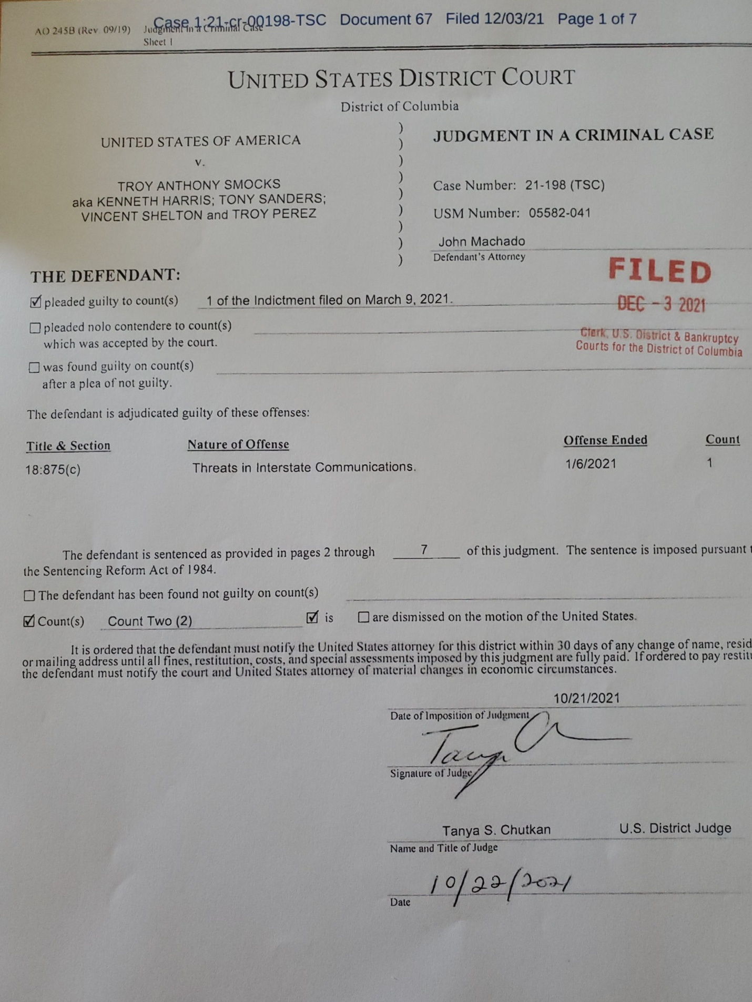

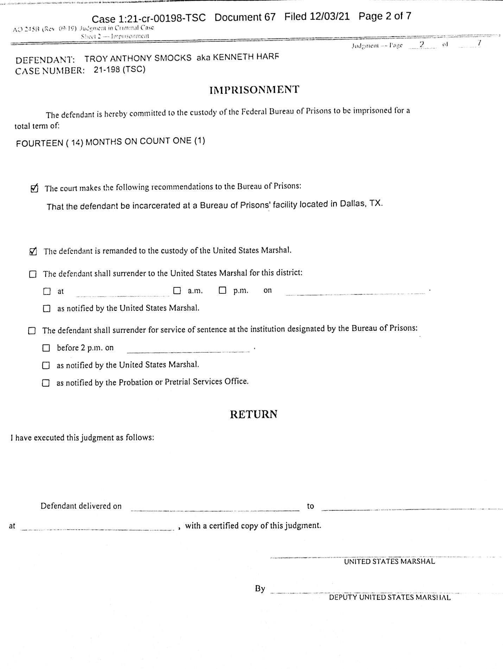

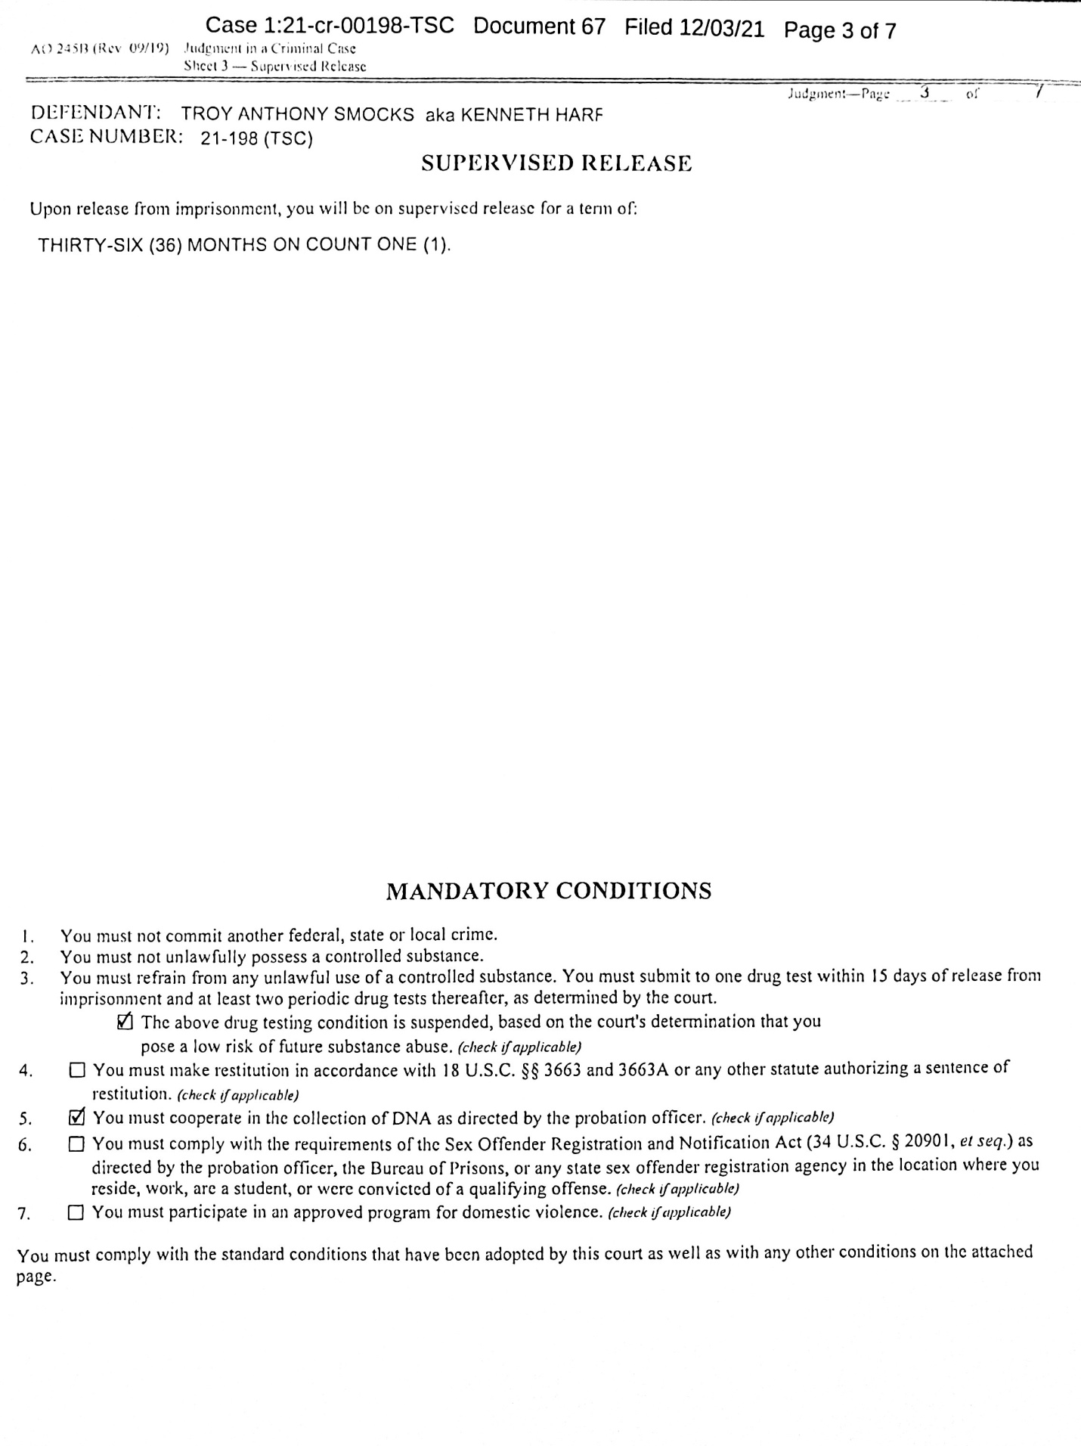
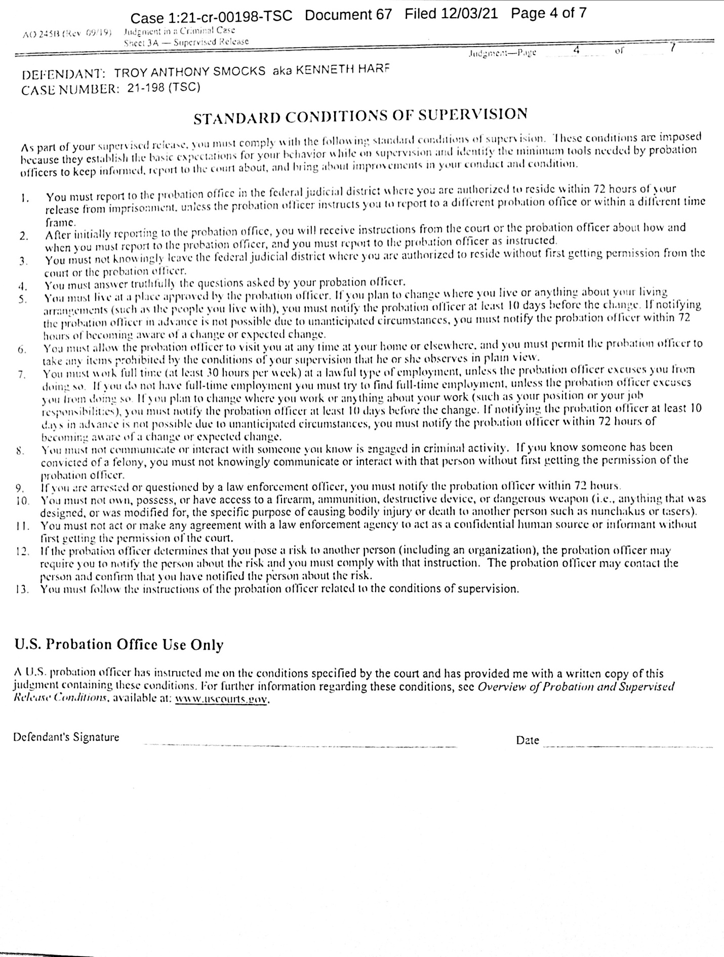

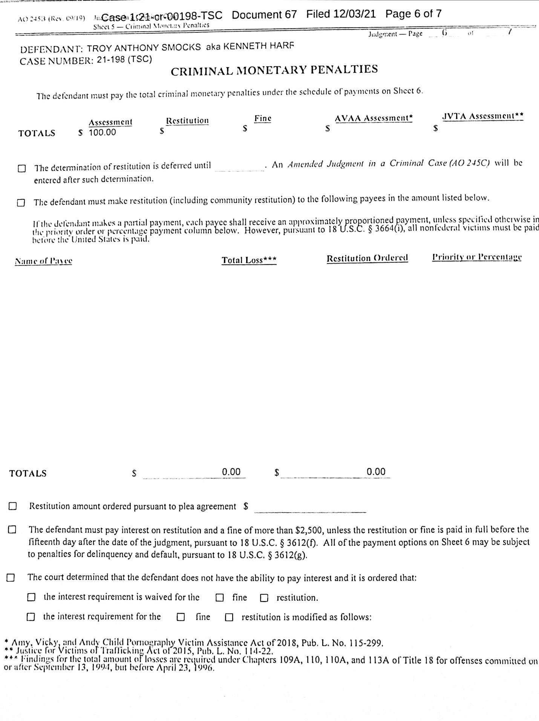
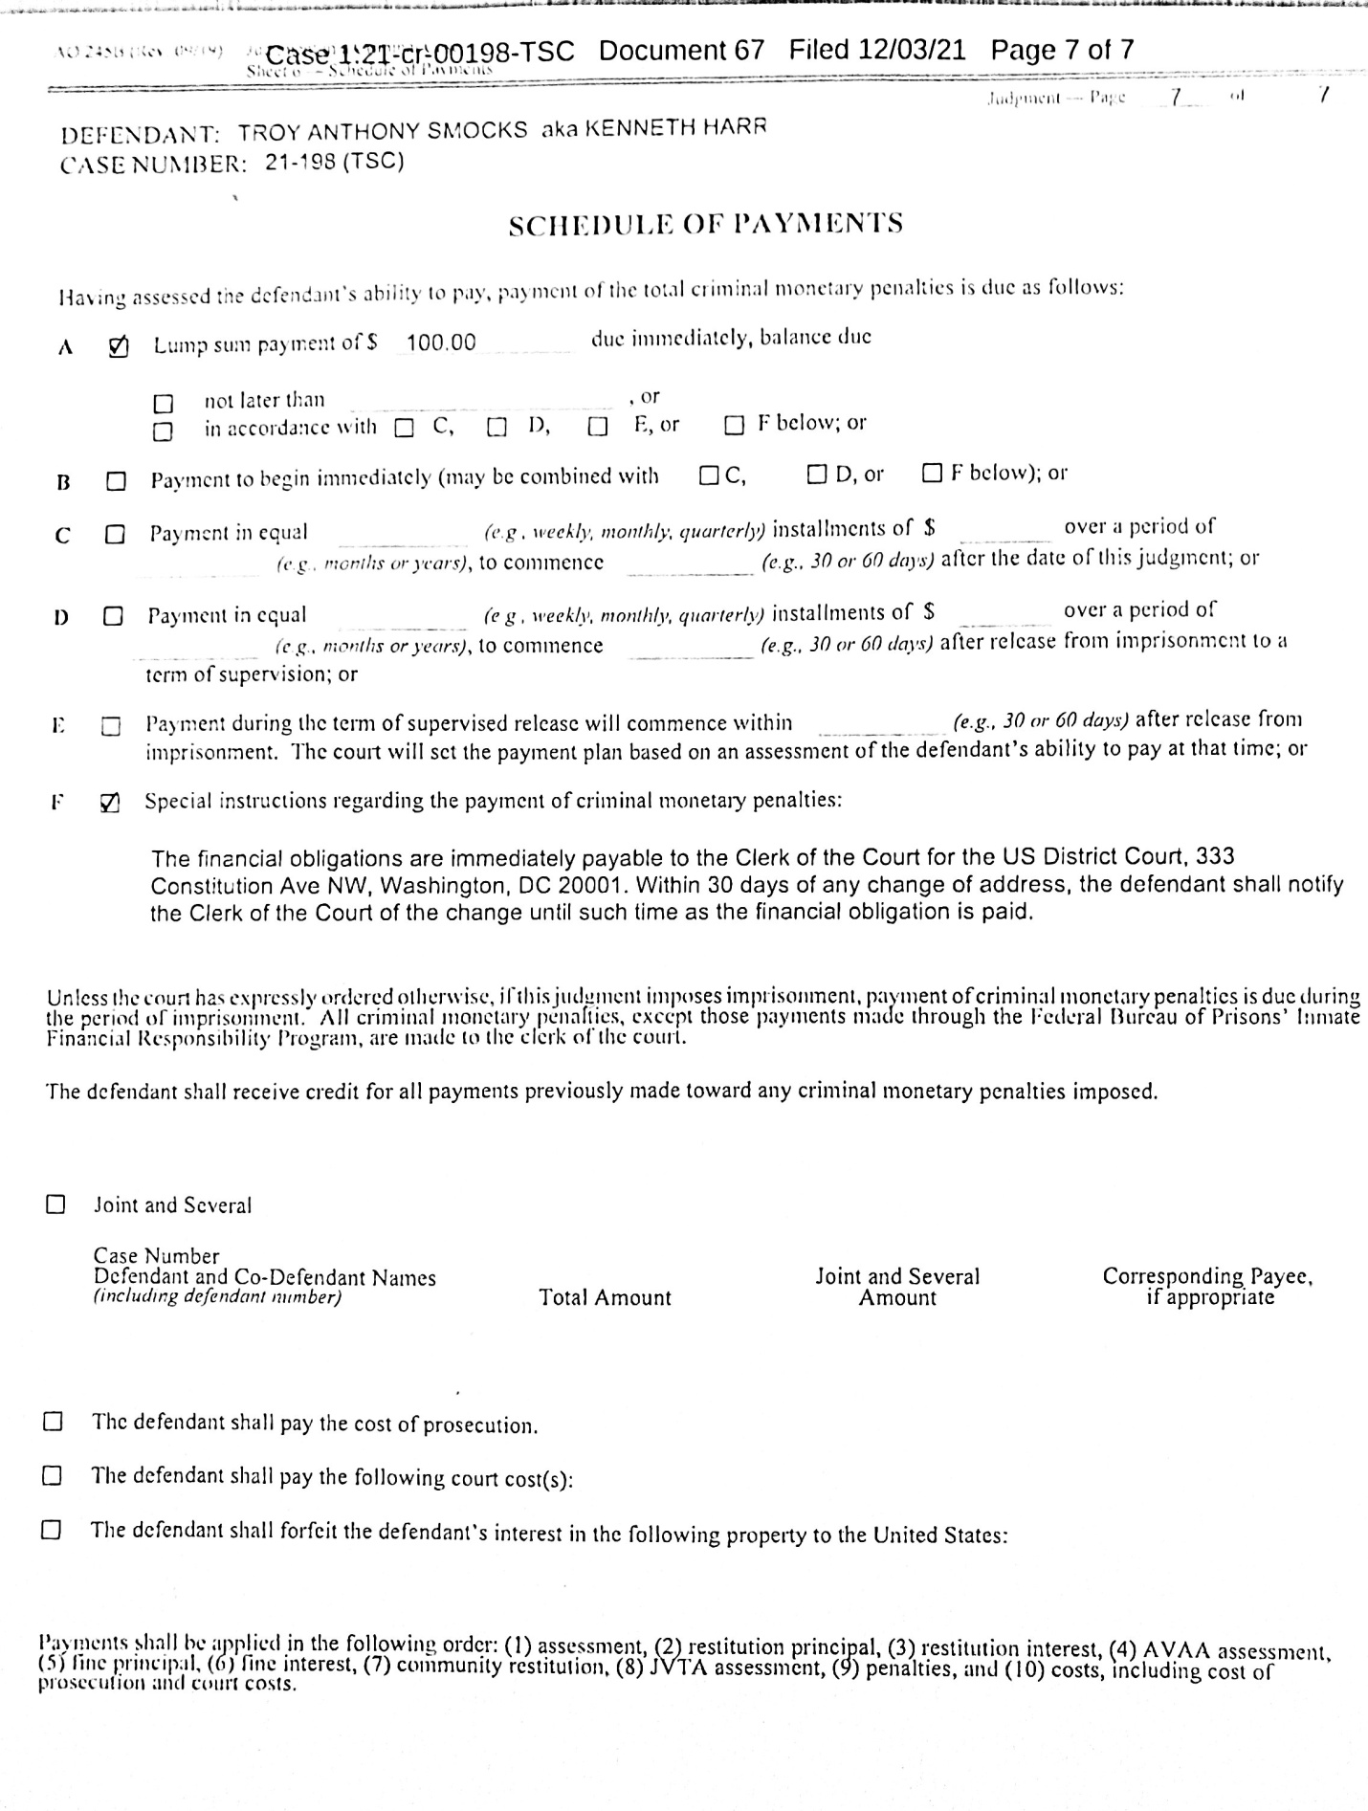

Sec. 276.001. RETALIATION AGAINST VOTER. (a) A person commits an offense if, in retaliation against a voter who has voted for or against a candidate or measure or a voter who has refused to reveal how the voter voted, the person knowingly: (1) harms or threatens to harm the voter by an unlawful act;
“We are sick and tired of the Republicans in Name Only surrendering to Joe Biden & the radical Left. Order your RINO Hunting Permit today!”

